# Sprint 2

**Software-** Create device in the IoT Watson Platform, workflow for IoT Scenarios using Local Node

|  |  |
| --- | --- |
| Date | 8 October 2022 |
| Team ID | PNT2022TMID23506 |
| Project Name | Project – Smart Farmer-IoT Enabled smart Farming Application |
| Maximum Marks | 4 Marks |

Launch IBM Watson IoT Platform:

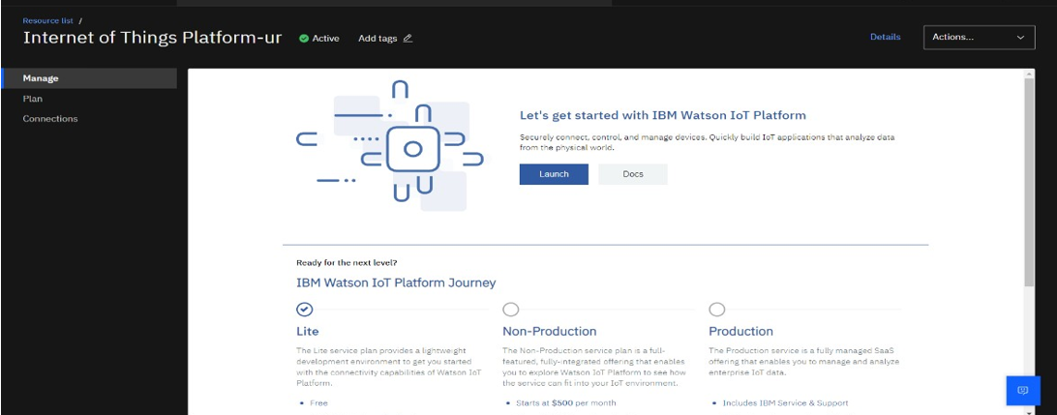

# Steps to configure:

* Create an account in IBM cloud using your email ID
* Create IBM Watson Platform in services in your IBM cloud account
* Launch the IBM Watson IoT Platform
* Create a new device
* Give credentials like device type, device ID, Auth. Token
* Create API key and store API key and token elsewhere.

Create a new device:

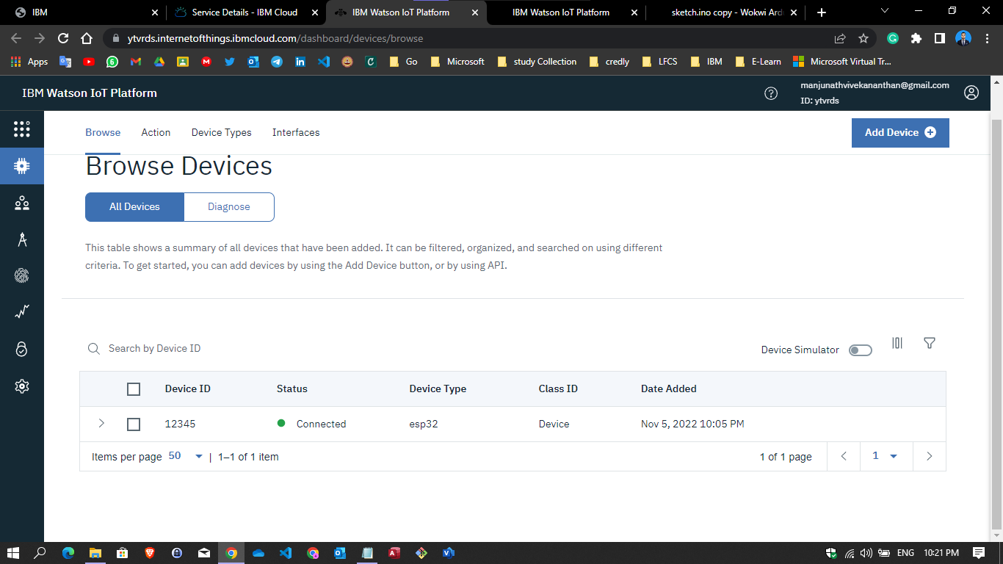

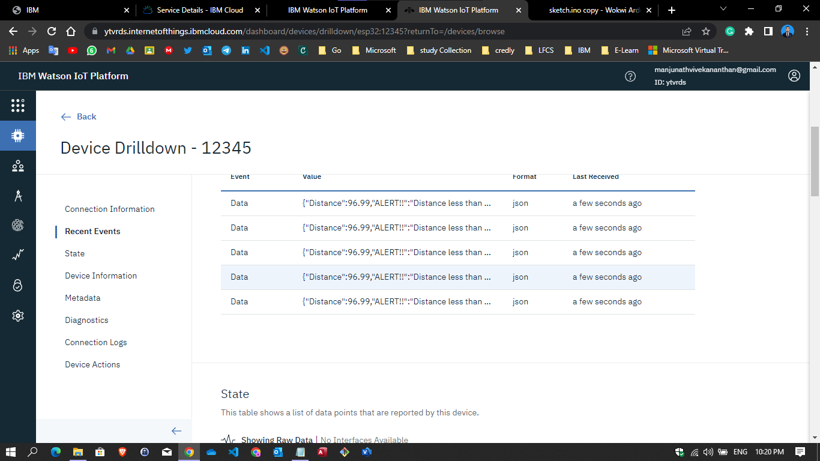

IoT Simulator:

In our project in the place of sensors we are going to use IoT sensor simulator whichgive random readings to the connected cloud.The link to simulator:<https://watson-iot-sensor-simulator.mybluemix.net/>

Connecting IoT Simulator to IBM Watson IoT Platform:

My credentials given to simulator are: Org:1xl08d

API: a-1xl08d-p5eyywn2eu

Auth Token:GpIJ5spsrx0ZB*RLmJ Device Type:abcd

Device ID:12

Device Token:12345678

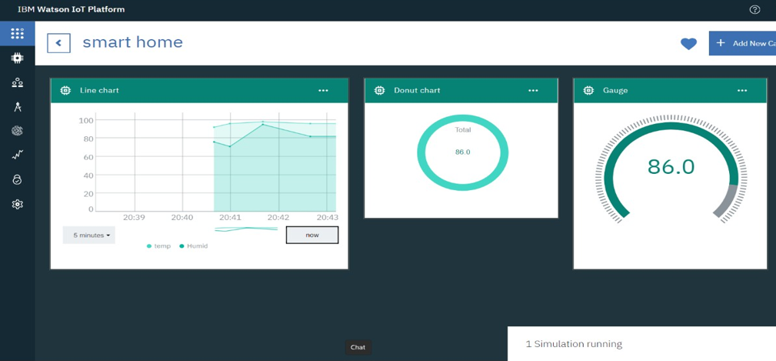

You can see the received data in graphs by creating cards in Boards tab

* You will receive the simulator data in cloud
* You can see the received data in Recent Events under your device
* Data received in this format(json)

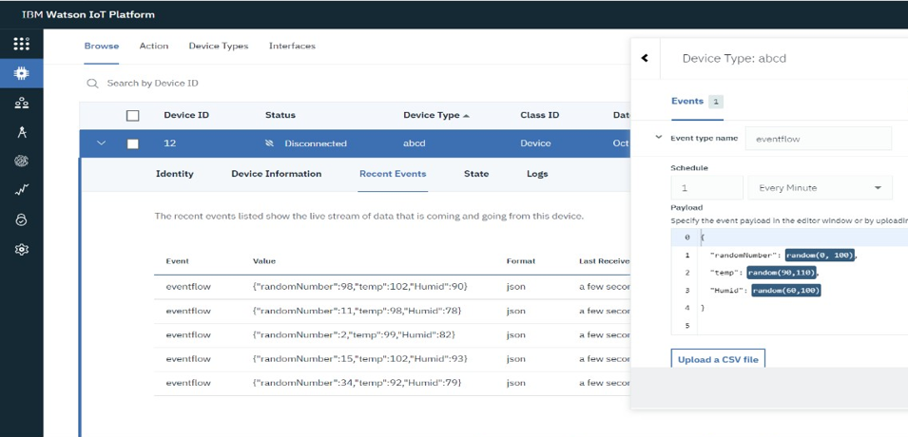

Configuring IBM-IoT to Node-RED connection

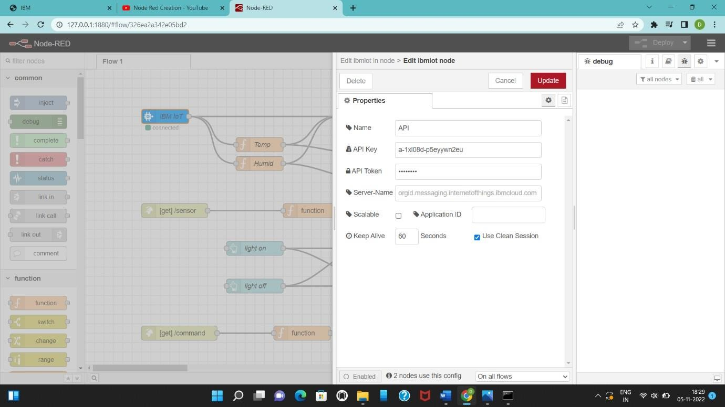

Installing a node-red-contrib-scx-ibmiotapp and node-red dashboard

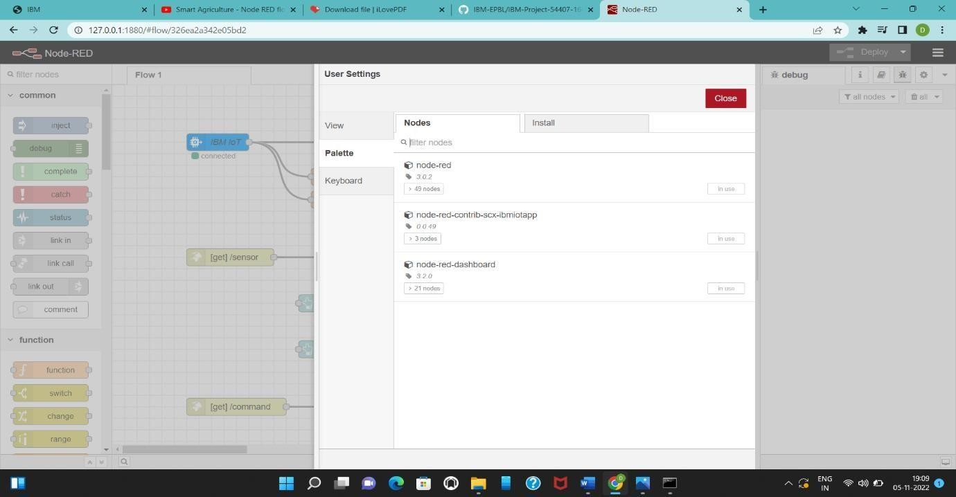

Complete Program Flow:

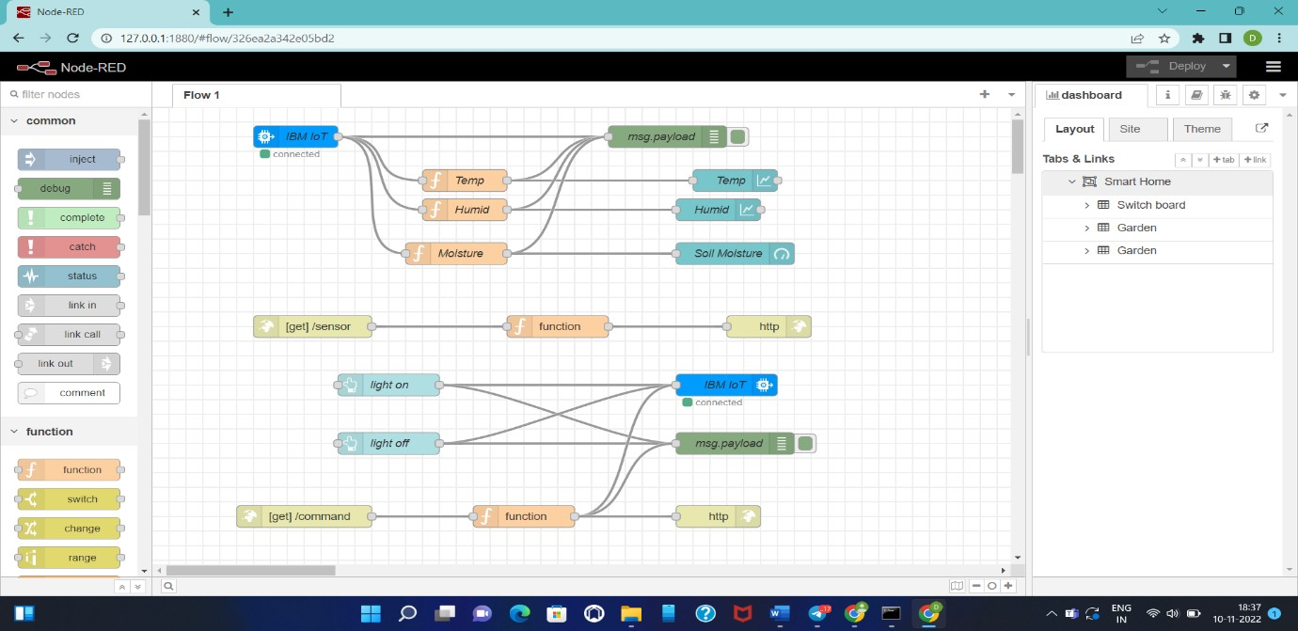

Configuration of Node-Red to collect IBM cloud data

The node IBM IoT App In is added to Node-Red workflow. Then the appropriate device credentials obtained earlier are entered into the node to connect and fetch device telemetry to Node-Red.

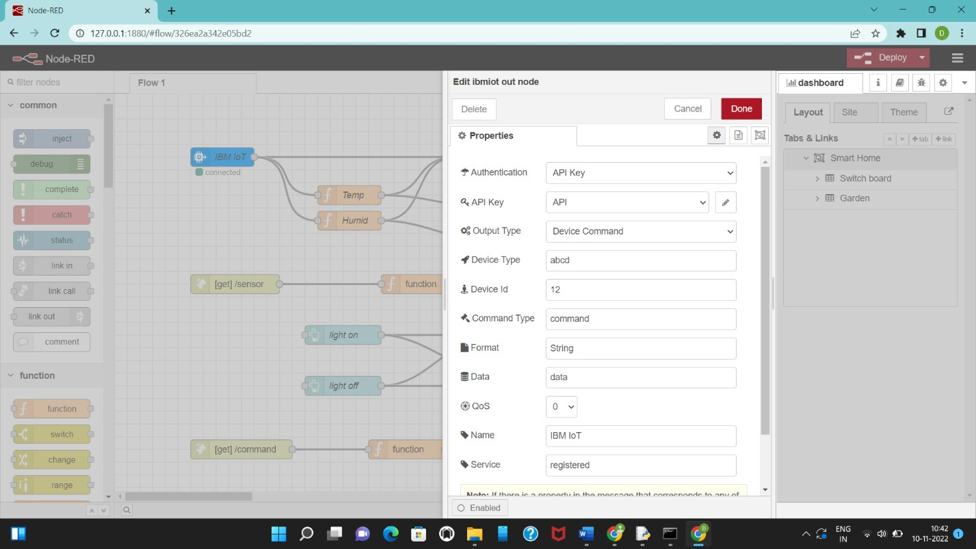

Connect function node and The Java Script code for the function node is:

msg.payload=msg.payload.temp return msg;

Finally connect Gauge nodes from dashboard to see the data in UI

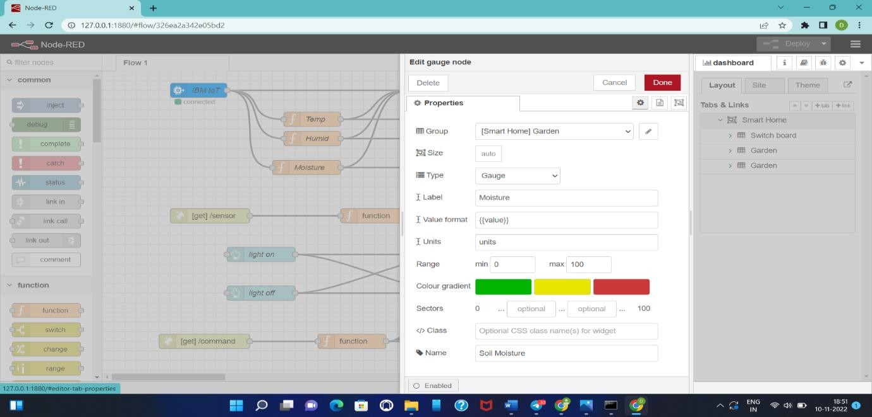

Configuration of Node-Red to collect data from OpenWeather

The Node-Red also receive data from the OpenWeather API by HTTP GET request.An inject trigger is added to perform HTTP request for every certain interval.

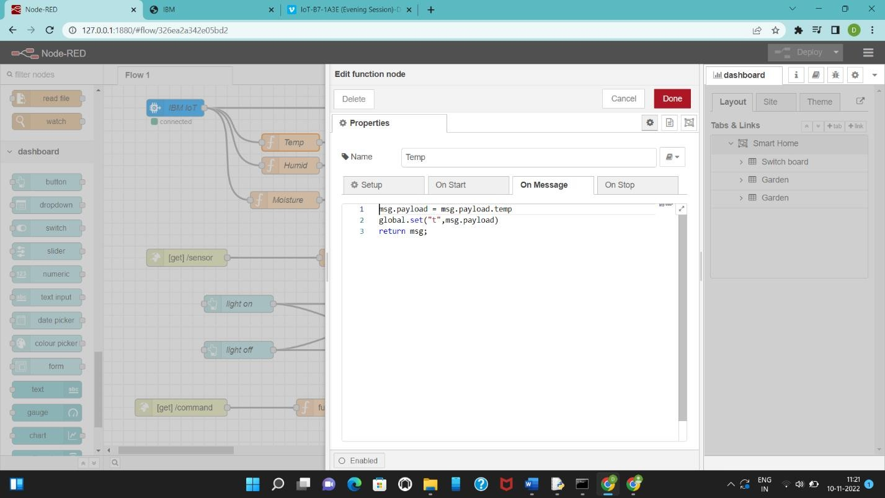

Checking IoT sensor Output in IBM Watson

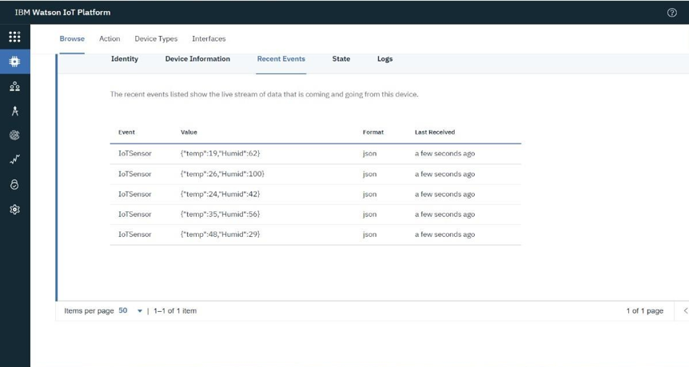

Checking IoT sensor using command in Node-RED

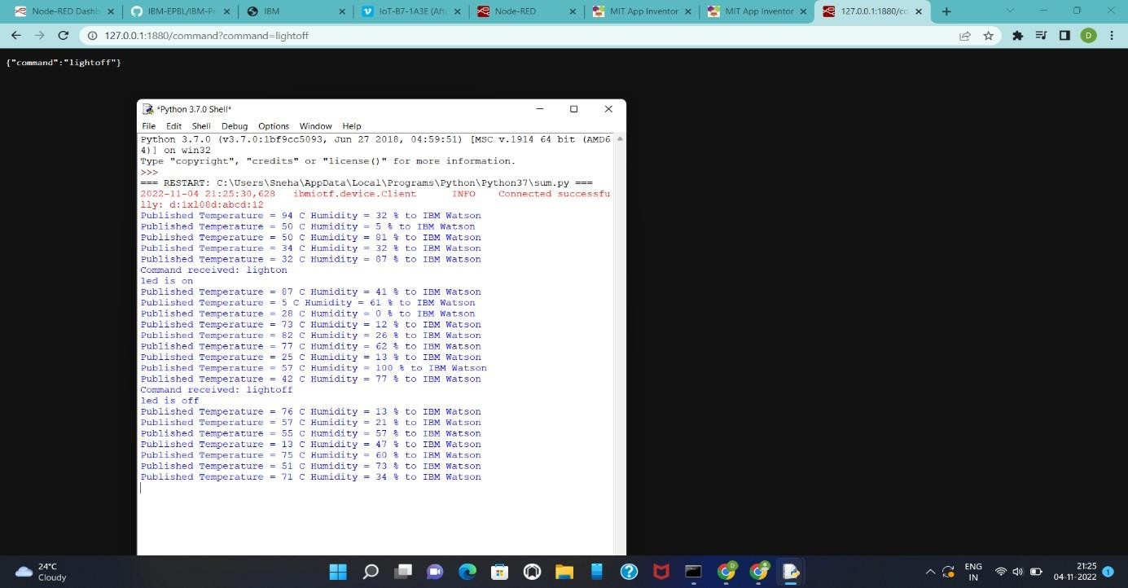

Output in Node-RED Dashboard:

